[ Monitoring-MySql-App-Using-Prometheus & Grafana ]

1. Creating an Ec2 on Aws setup Prometheus server

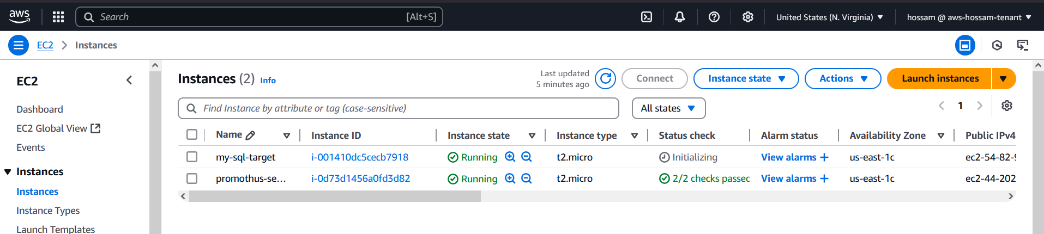

1. Security Group open ports needed to Prometheus server :

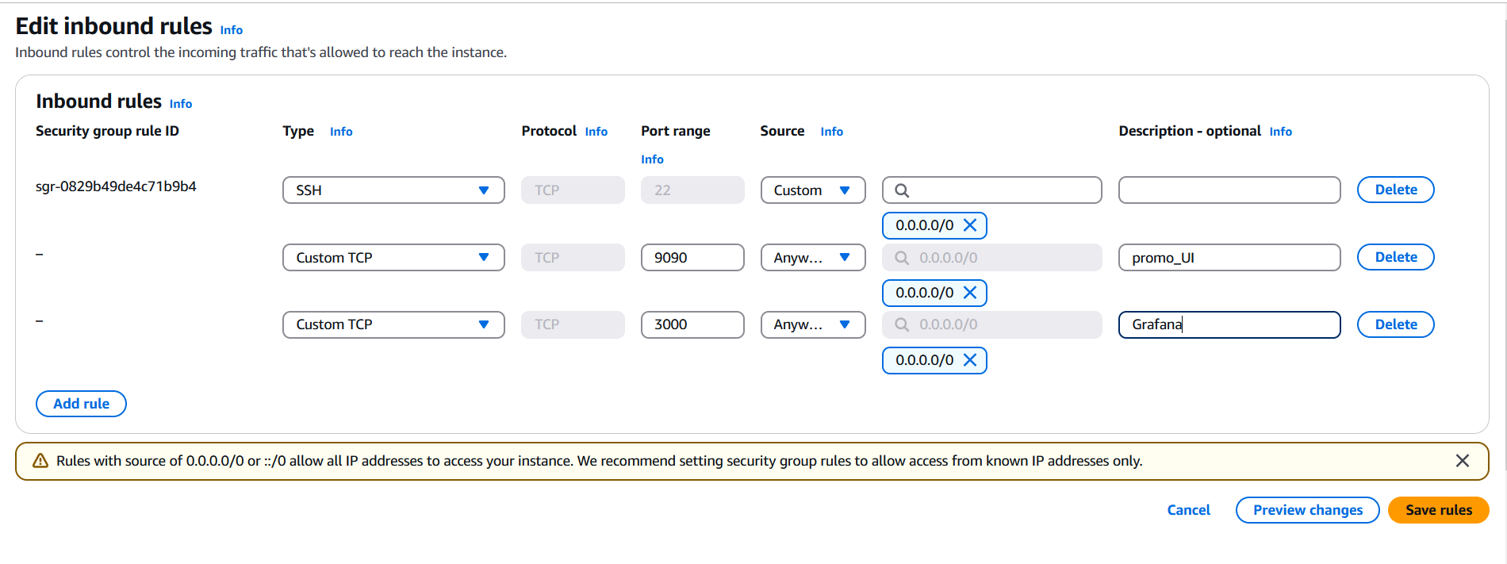

1. Configure & install Prometheus server (run as a systemd)

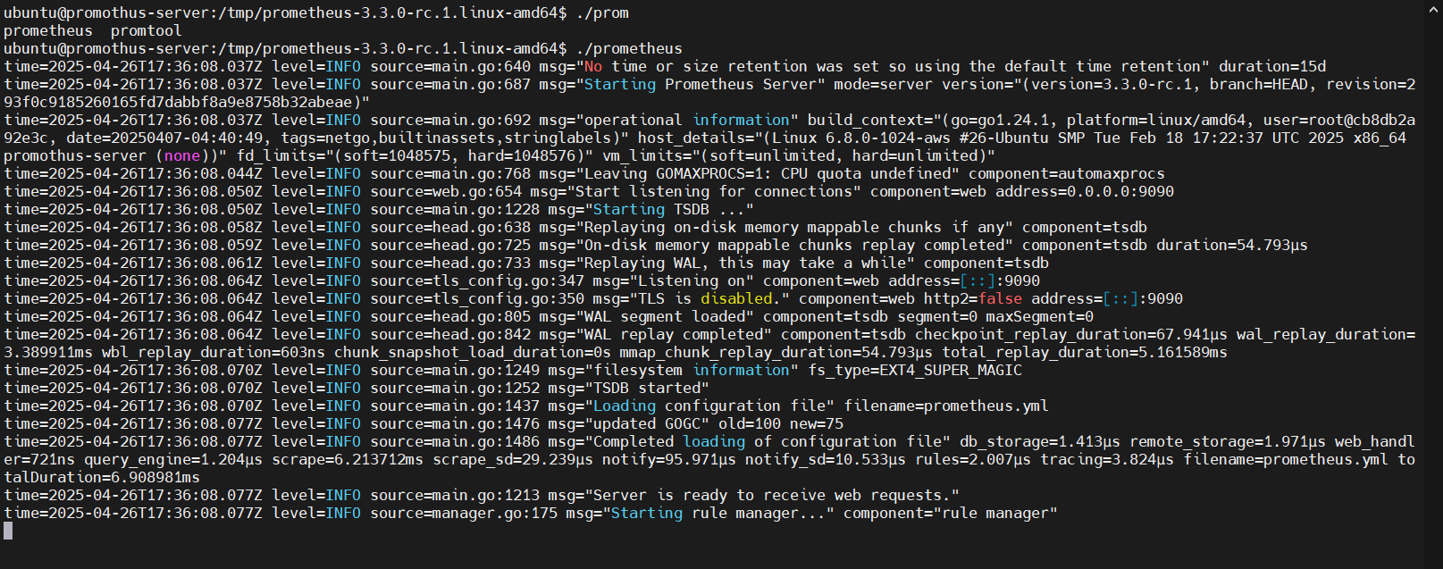

Discover UI : http://<ec2-public-ip>:9090

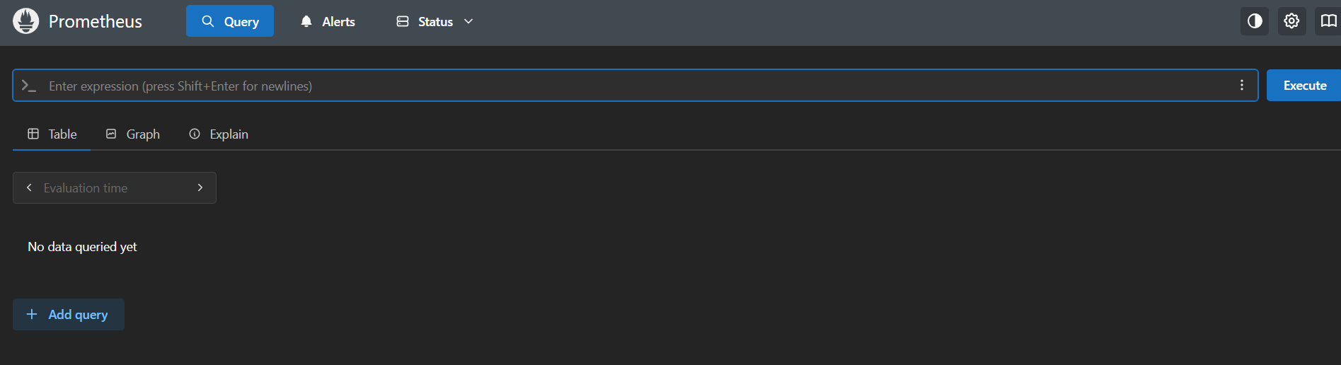

Run as a systemd :

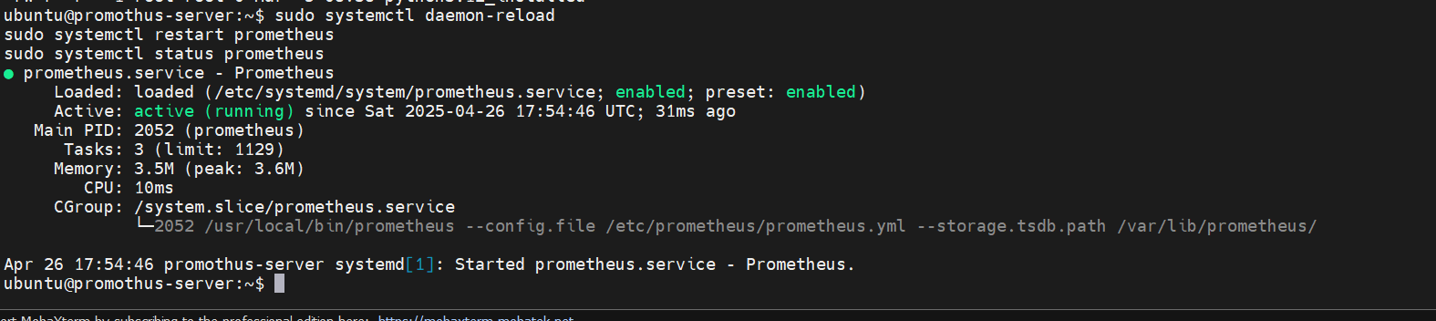

Prometheus and monitor up :

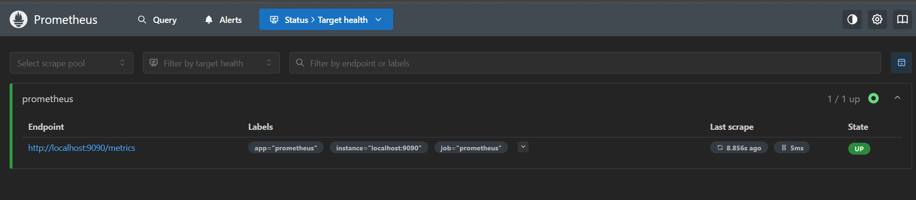

What is this target Prometheus monitor itself to check?

# this information in configuration file

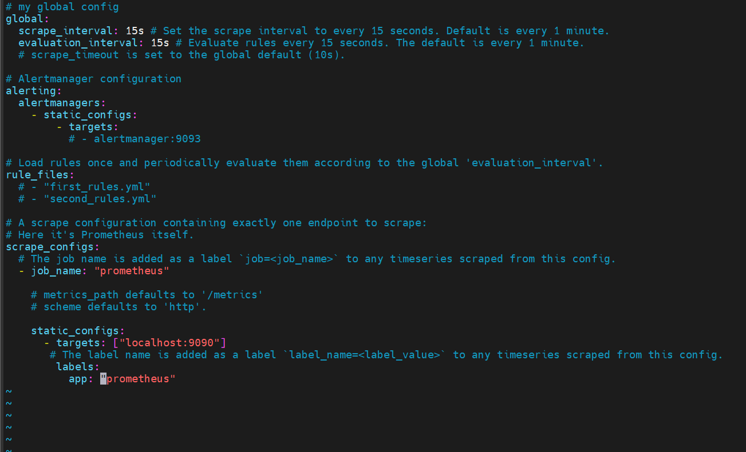

2- setup a mysql node as a target

First : install & prepare server as mysql server :

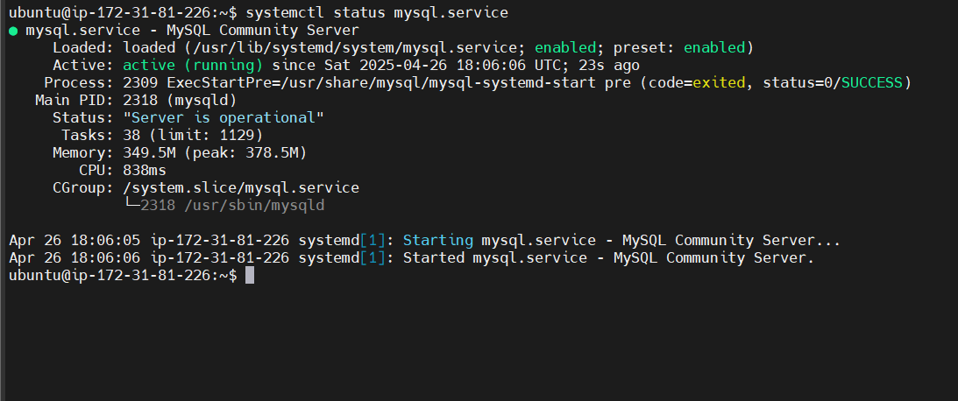

Second : install exporter & setup



Third : enter to Db and create user & give permission to exporter   
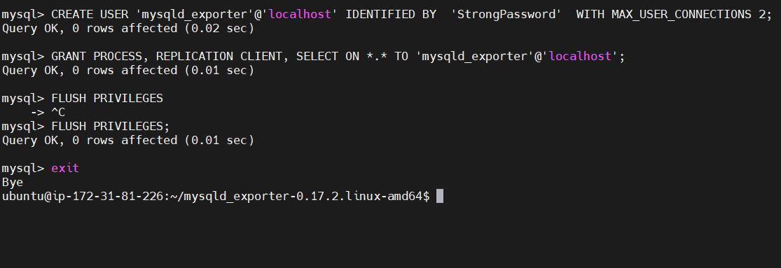

fourth : mysql exporter as a service

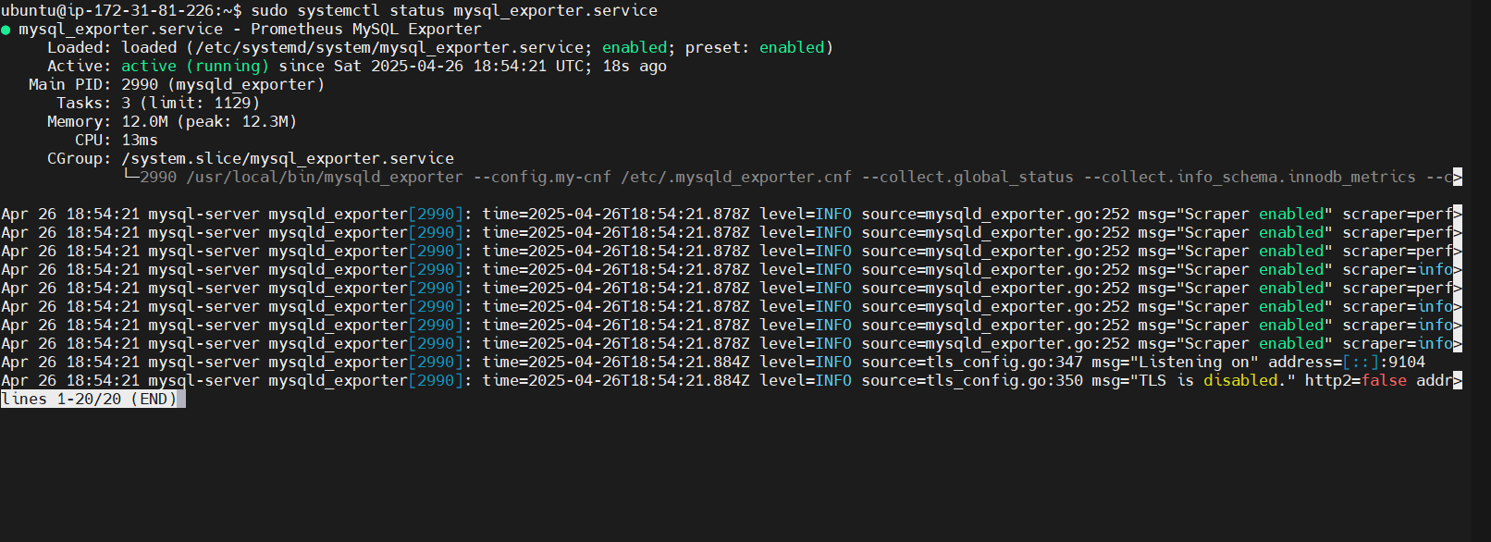

Validation :

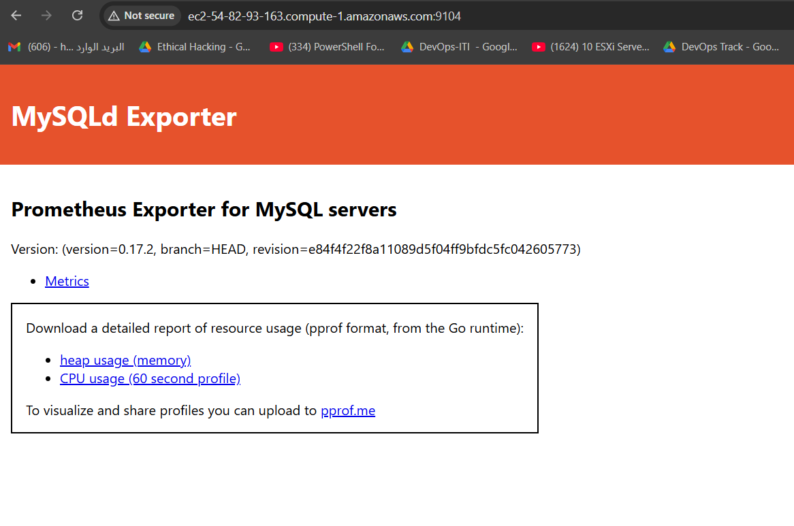

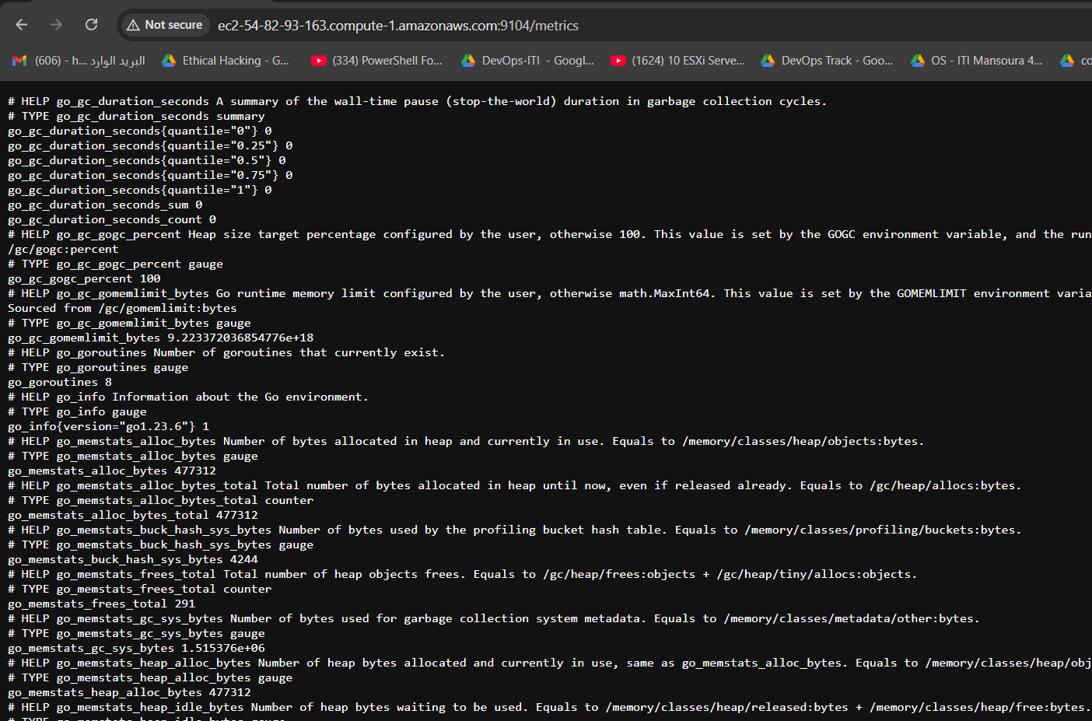

Configure target and add to Prometheus server :

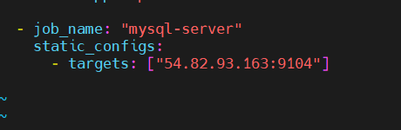

# sudo systemctl restart prometheus.service  
  
  
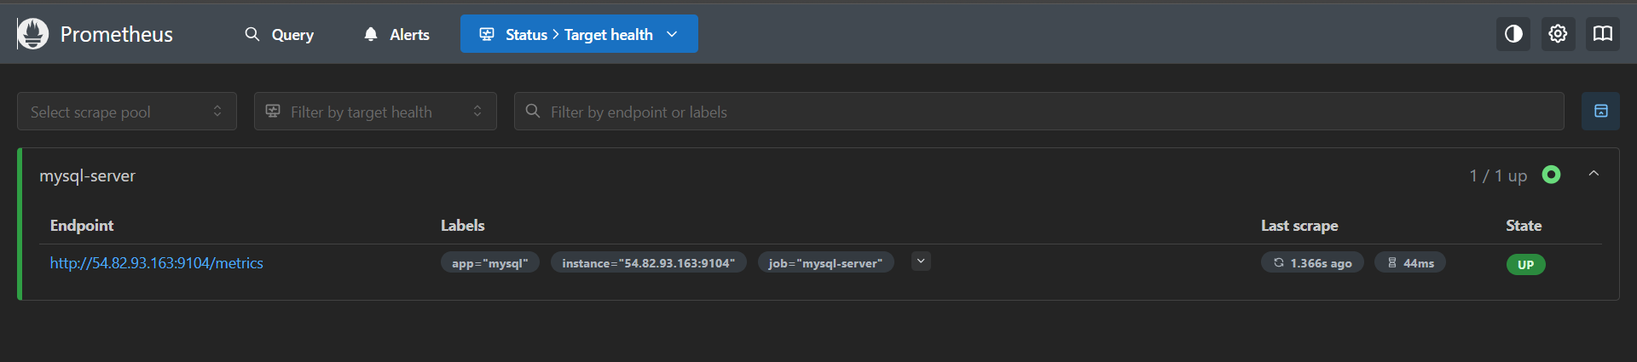

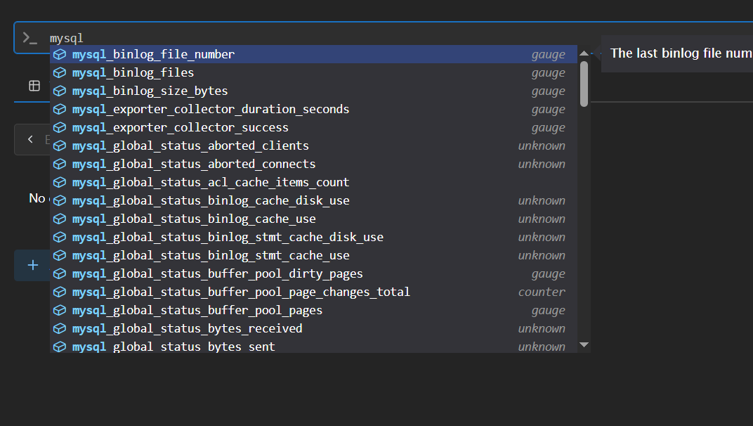

3- install Grafana and integrate with Prometheus

// install Grafana as a docker container

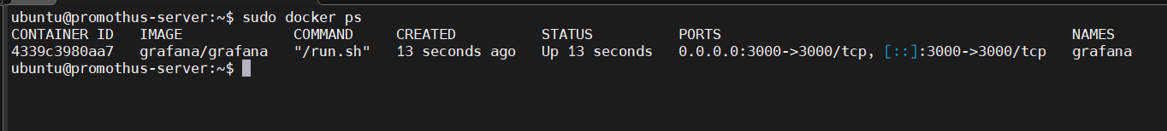

Open :  
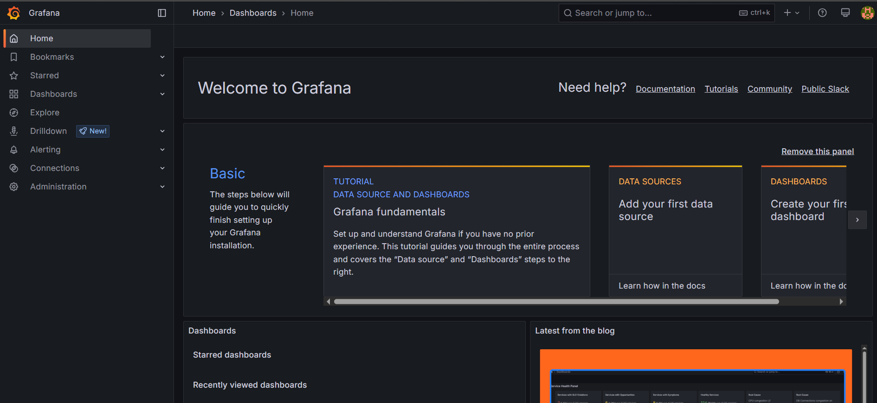

Add data source -> Prometheus server   
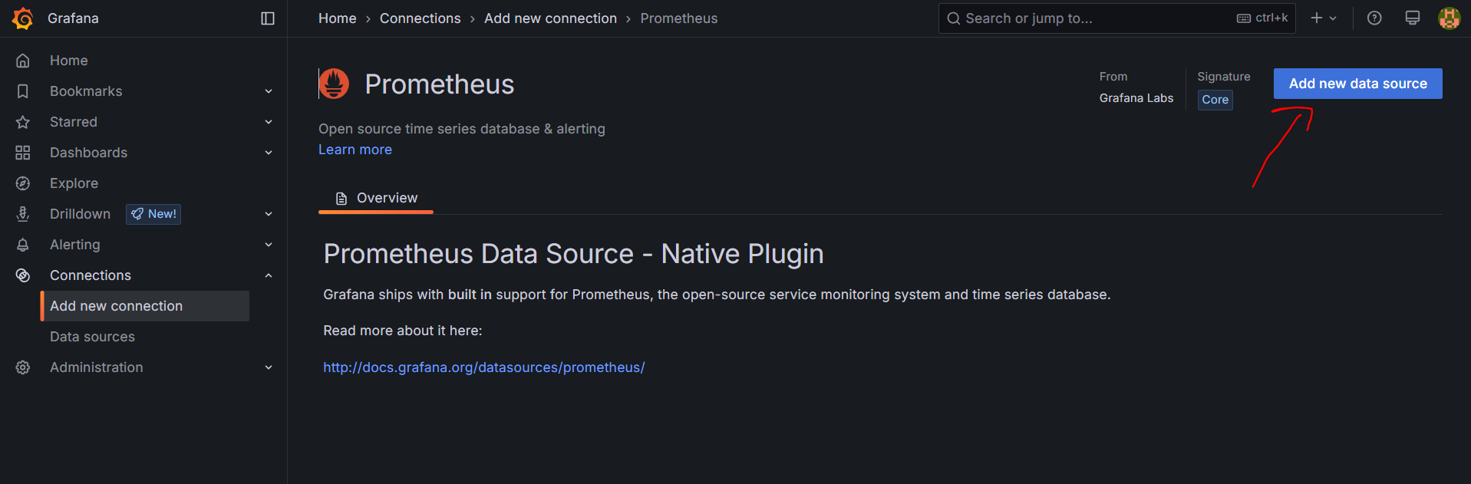

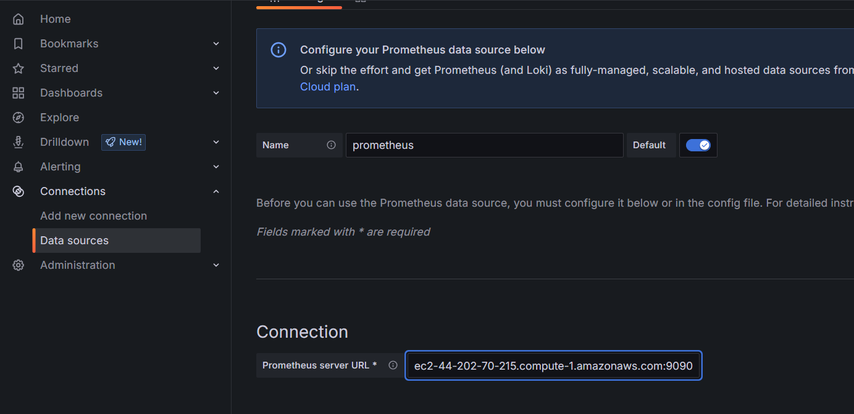

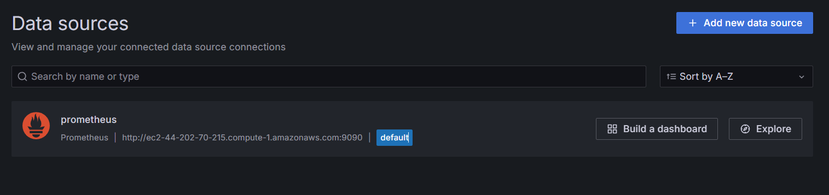

import Dashboard for mysql :

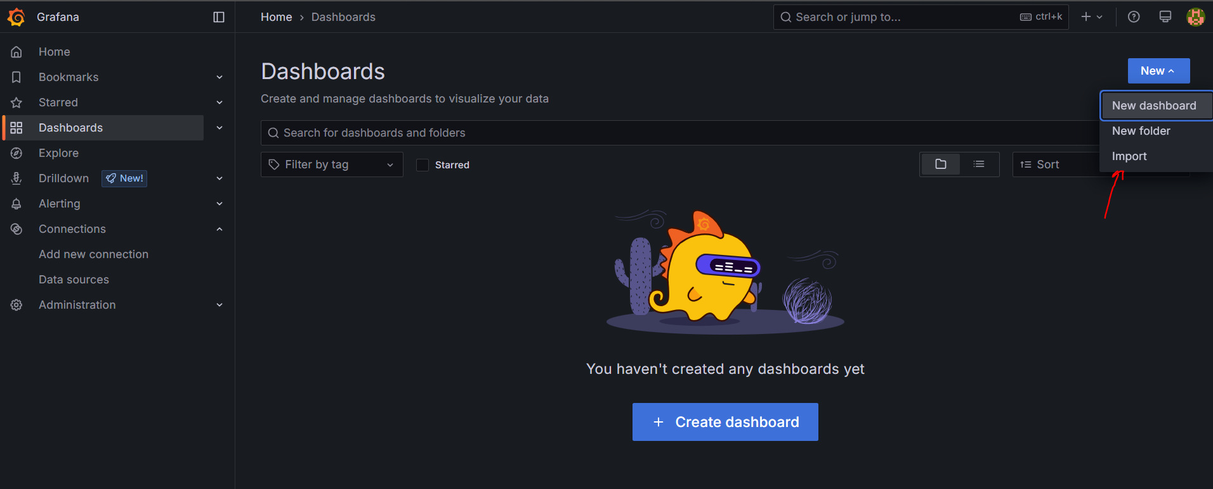

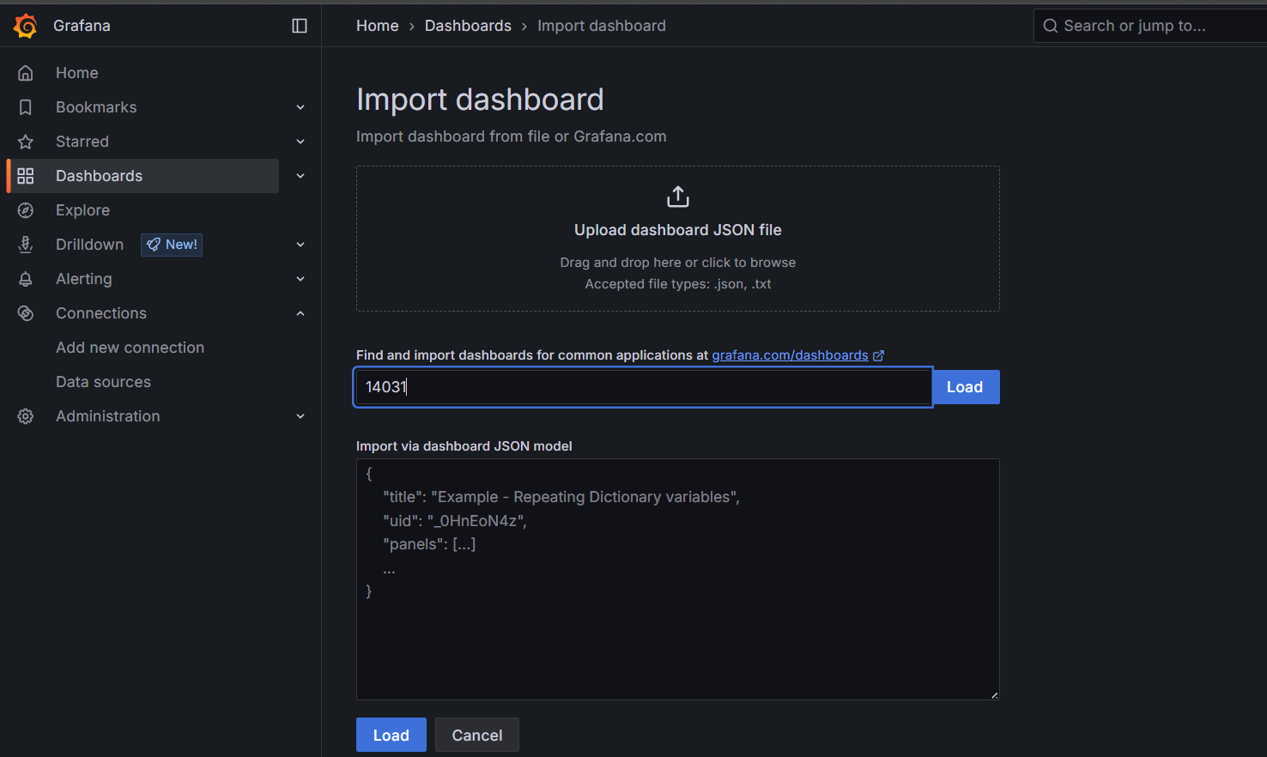

Final Result :  
  
  
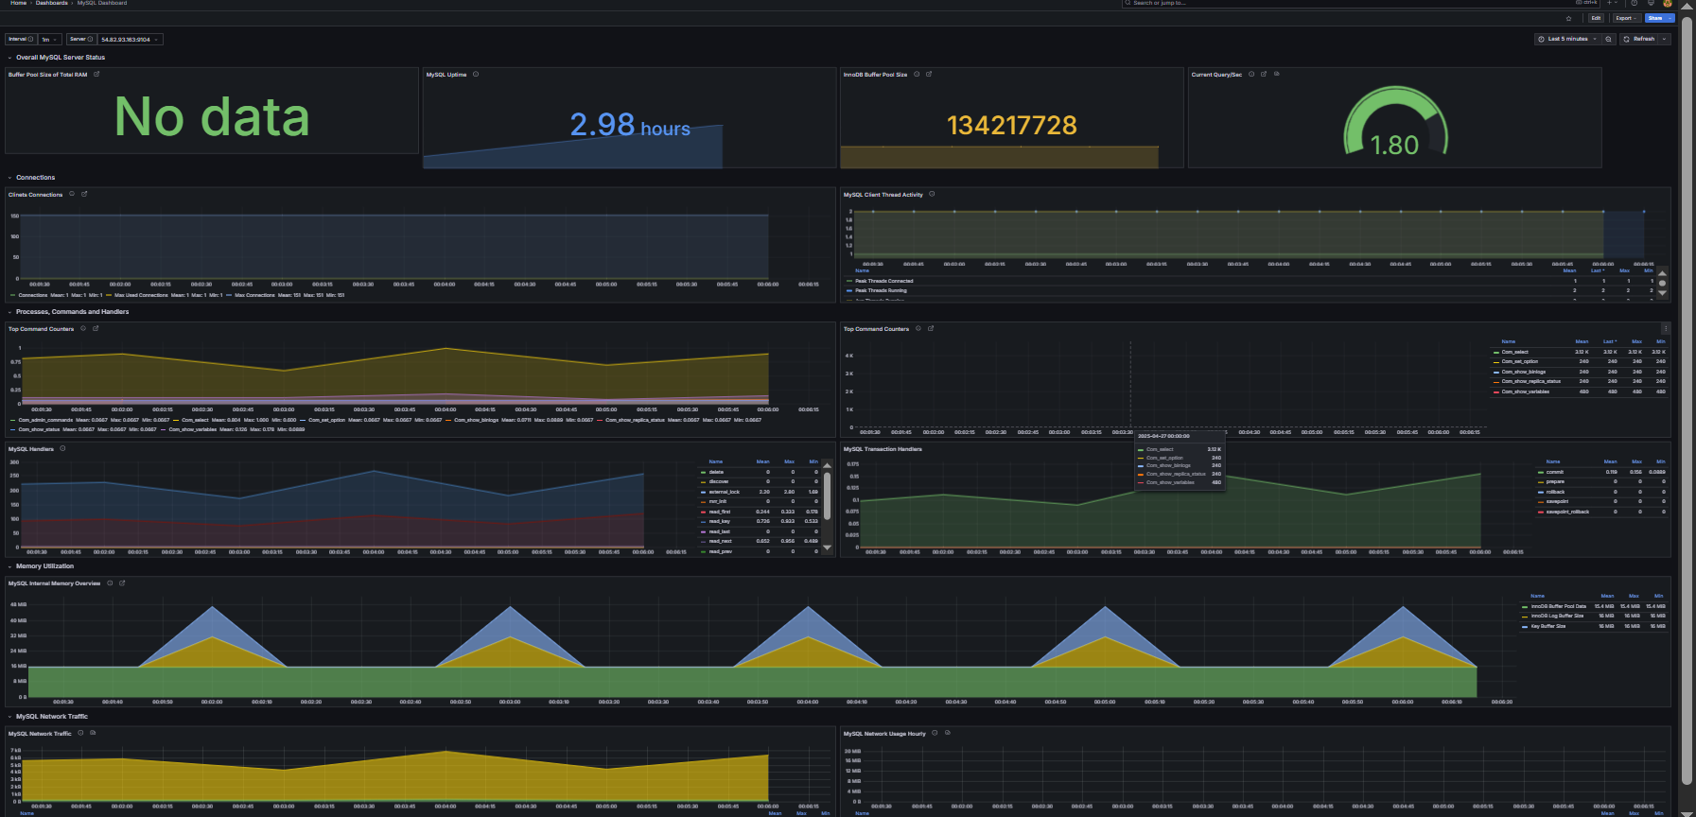  
  
  
  
  
  
  
  
  
  
  
  
  
  
  
  
  
  
  
  
  
congratulations🎉🎉🎉🎉🎉🎉